Supplemental material for

**Seasonal metal fluxes derived by the interaction of surface water and groundwater in an aquaculture estuary**

**Contents of this file**

Supplementary 222Rn Box model

Table S1-S3

Figure S1-S2

* 1. **222Rn Box model**

The 222Rn BOX model is a mass balance model, and the sources term and sinks term are established as equations to solve the unknown term. Assuming that the system is in steady state. In this study, the source phases include: 226Ra decay (FRa-226), river input (Friv), sediment diffusion (Fsed), SGD input (FSGD), high tide input (Fin); The sink items include: 222Rn decay (FRn-222), atmospheric evasion (Fatm), mixing loss (Fmix), ebb tide output (Fout). The calculation methods of each sources and sinks term need to select the end member and cooperate with the corresponding empirical formula to calculate:

FSGD+(Fin-Fout)+(Friv-Fmix)+(Fsed-Fatm)+(FRa-226-FRn-222)=△F (1a)

Fx as the rate of each endmember (Bq m-2 h-1), △F is the time interval for the inventory variation:

(1b)

* 1. Radon and Radium decay:

For radionuclides (222Rn, 226Ra), decay of 222Rn's parent 226Ra increases it, and decay of 222Rn itself decreases it.

FRa-226=CRa-226×λRn-222×h(t) (2a)

CRa-226 is the average activity of 226Ra in the study area, λRn-222 is the decay constant of 222Rn, h(t) is the depth (m) of time series station at the time of t.

$F_{Rn-222}\left(t\right)=\left[C_{Rn-222}\left(t\right)×(1-e^{-λ_{Rn-222}×∆t})\right]×λ_{Rn-222}×h\left(t\right)$ (2b)

CRn-222 (t) is the 222Rn activity (Bq m-3) at time t in the study area, Δt is the time interval (1hour).

* 1. Radon diffusion between the sediment-water and atmospheric-water:

222Rn can be released into seawater through diffusion, and this part of 222Rn is generated by the decay of 226Ra in the sediments, which can be obtained through the culture experiment of the sediments and the corresponding formula:

$F_{sed}={(λ_{Rn-222}×φ×D_{m})}^{0.5}×(C_{eq}-\overline{C_{Rn-222}})$ (3a)

φ is sediment porosity, $\overline{C_{Rn-222}}$ is the average 222Rn activity in the sea water, Ceq is the 222Rn activity in pore water calculated through the sediment incubation experiment, and the formula is:

$C_{eq}=\frac{C_{eq}^{*}×V}{\frac{m}{ρ}×φ}$ (3b)

Where is the 222Rn activity (Bq m-3) directly obtained in the sediment incubation experiment, V is the volume of seawater, and m is the mass of wet sediment (kg), ρ is the density of wet sediment (kg m-3), Dm is the molecular diffusion coefficient, which can be calculated by the following formula:

$D_{m}={10}^{-\left(\frac{980}{T+273}+1.59\right)}$ (3c)

At the same time, as a gas, 222Rn in seawater will diffuse to the atmosphere and cause losses:

$F_{atm}\left(t\right)=K_{600}×\left(C_{Rn-222}\left(t\right)-α\overline{C_{air}}\right)$ (3d)

$\overline{C_{air}}$ is the average 222Rn concentration in the air (Bq m-3), α is the water-vapor distribution coefficient of 222Rn,, which can be calculated by the formula (3e), k600 is the gas transfer rate of 222Rn, which is obtained by the normalization of the Schmidt number of carbon dioxide at 20℃.

α=0.105+0.405×e-0.0502T (3e)

${K_{600}\left(t\right)=\{}_{{0.45×{u\left(t\right)}^{1.6}×\left({Sc}/{600}\right)}^{-\frac{2}{3}} (u≪3.6 m s^{-1})}^{{0.45×{u\left(t\right)}^{1.6}×\left({Sc}/{600}\right)}^{-\frac{1}{2}} (u>3.6 m s^{-1})}$ (3f)

u(t) (m s-1) is the wind speed at time t and Sc is Schmidt number at a certain water temperature:

(3g)

* 1. Radon transport by ebb and flood tides:

In the nearshore environment, the ebb and flood tide will cause the change of 222Rn inventory (Bq m-2). The 222Rn activity is low in offshore sea water. When the tide rises, 222Rn with low activity in the open sea influx into the nearshore. This will cause the 222Rn activity decrease. When in ebb tide, 222Rn with high activity near shore is carried offshore:

$F_{in}\left(t\right)=\frac{h_{t+∆t-}h_{t}}{∆_{t}}×(b×Cw+(1-b)×C_{off})$ (4a)

$F_{out}\left(t\right)=\frac{h_{t}-h_{t+∆t}}{∆t}×C_{Rn-222}\left(t\right)$ (4b)

Cw is the average activity of 222Rn at the TS station (Bq m-3); Coff is the offshore 222Rn activity, we use the lowest 222Rn activity of time series observation to instead; b is the return flow factor.

* 1. River input and mixing loss:

Our study area is close to the Aojiang estuary, so the river may support 222Rn and the 222Rn activity of the river is usually higher than that of the coastal seawater:

$F_{riv}=\frac{C_{riv}×Q_{riv}}{A}$ (5a)

Criv is the average 222Rn activity of the river (Bq m-3); Qriv is the river flux; A is the area of the estuary. Because of the positive activity gradient of 222Rn activity from nearshore to offshore, the 222Rn will transport by water mixing. However, the mixing effect of 222Rn is difficult to be determined by direct method. We use conservative estimation method to instead:

Define Fnet:

Fnet=△F-FRa-226+FRn-222-Fin+Fout-Fsed+Fatm-Friv (5b)

We can obtain:

 FSGD=Fnet+Fmix (5c)

Assume that SGD ≥ 0, then Fnet+Fmix ≥ 0, so Fmix is less than or equal to the reciprocal of Fnet, and Fmix cannot be less than or equal to zero (Burnett and Dulaiova, 2003; Chen et al., 2018). Fmix can be obtained by the above estimation, and the contribution of FSGD (Bq m-2 h-1) can finally be obtained (All specific data are available in Table S2). After FSGD is determined, the flux of groundwater can be obtained by dividing the 222Rn concentration of end member (Porewater):

$V_{SGD}=\frac{F_{SGD}}{C_{Rn}}$ (2)

Table S1. Parameters used in the 222Rn-Box model

|  |  |  |  |  |  |  |
| --- | --- | --- | --- | --- | --- | --- |
| Items |  | July |  | October |  | April |
| CRa-226 （Bq m-3） |  | 4.85 |  | 4.85 |  | 4.85 |
| λRn-222 （d-1） |  | 0.181 |  | 0.181 |  | 0.181 |
| △t (h) |  | 1 |  | 1 |  | 1 |
| φ |  | 0.316 |  | 0.316 |  | 0.316 |
| $\overline{C_{Rn-222}}$ (Bq )   |  | | --- | |  | |  | 268 |  | 186 |  | 131 |
| Ceq (Bq m-3) |  | 11743 |  | 18805 |  | 7073 |
| |  | | --- | |  | |  | 375 |  | 601 |  | 224 |
| Cw (Bq m-3) |  | 77.3 |  | 70.2 |  | 92.1 |
| V (mL) |  | 475 |  | 475 |  | 479 |
| m (kg) |  | 0.1 |  | 0.1 |  | 0.1 |
| ρ (kg m-3) |  | 2086 |  | 2086 |  | 2086 |
| Dm (×10-5 cm2 s-1) |  | 1.34-1.46 (1.37) |  | 1.21-1.28 (1.26) |  | 1.16-1.18 (1.17) |
| |  | | --- | |  | |  | 0.201-0.219 (0.213) |  | 0.228-0.242 (0.232) |  | 0.249-0.254 (0.253) |
| k600 (cm h-1) |  | 0-9.21 (1.94) |  | 2.56-20.0 (7.96) |  | 0-7.38 (1.58) |
| ν20℃(×10-6 m2 s-1) |  | 1.004 |  | 1.004 |  | 1.004 |
| Coff (Bq m-3) |  | 40.0 |  | 37.9 |  | 58.2 |
| b* |  | 0.75 |  | 0.94 |  | 0.94 |
| Qriv (m3 s-1) |  | 97 |  | 33 |  | 81.5 |
| A (×107 m3) |  | 5.4 |  | 5.4 |  | 5.4 |
| Wind speed (m s-1) |  | 0-6.40 (2.23, n=27) |  | 3.20-11.2 (6.10, n=27) |  | 0-6.40 (2.22, n=20) |

CRa-226 is the mean 226Ra activity, λRn-222 is the 222Rn decay constant, △T is the interval time, φ is the sediment porosity, $\overline{C_{Rn-222}}$ (Bq ) is the 222Rn activity of offshore seawater, Ceq is the equilibrium activity of 222Rn obtained from sediment diffusion experiment, is the 222Rn activity that got directly from the equilibrium experiments, Cw is the average 222Rn activity of time series station, V is the volume of seawater used in the sediment diffusion experiment, m is the sediment mass used in the sediment diffusion experiment, ρ is the sediment density, Dm is the molecular diffusion coefficient, α is the partition coefficient of 222Rn, k600 isthe gas transfer velocity, ν20℃ is the dynamic viscosity coefficient of water at 20℃, Coff is the lowest 222Rn activity of the offshore seawater, and is replaced by the lowest 222Rn activity of the time series station, b* is the return flow factor, Qriv is the flux of the river.

Table S2. Summary of parameters of different water masses bodies in different seasons.

|  |  |  |  |  |  |  |  |  |  |  |  |  |
| --- | --- | --- | --- | --- | --- | --- | --- | --- | --- | --- | --- | --- |
|  | Wellwater | | | Riverwater-mixing | | | Seawater-mixing | | | Porewater | | |
|  | July-2019 (n=6) | October-2019 (n=6) | April-2021 (n=3) | July-2019 (n=5) | October-2019 (n=1) | April-2021 (n=2) | July-2019 (n=11) | October-2019 (n=18) | April-2021 (n=20) | July-2019 (n=3) | October-2019 (n=6) | April-2021 (n=10) |
| Temperature (℃) | 22.0-26.0 (23.4±1.66) | 22.4-30.1 (27.5±2.88) | 19.0-20.5 (19.9±0.814) | 26.8-27.5 (27.1±0.332) | 24.2 | 20.41-21.58 (21.0±0.827) | 25.5-28.1 (26.8±0.903) | 21.5-24.6 (23.4±0.756) | 19.2-21.2 (20.2±0.545) | 24.8-25.3 (25.0±0.251) | 20.7-28.6 (24.3±3.39) | 19.4-22.1 (20.3±0.872) |
| Salinity | 0-0.1 (0.0800±0.0447) | 0.100-0.300 (0.217±0.0651) | 0-0.2 (0.1±0.100) | 0-25.4 (11.8±10.1) | 29.1 | 16.8-28.2 (22.5±8.09) | 3.95-26.2 (18.5±6.60) | 25.9-29.6 (27.2±1.13) | 21.8-31.3 (27.2±2.99) | 24.9-25.7 (25.2±0.436) | 12.5-14.3 (13.5±0.619) | 28.5-29.3 (28.9±0.264) |
| pH | 7.45-7.82 (7.67±0.170) | na | 7.14-8.92 (7.86±0.939) | 7.93-8.21 (8.08±0.119) | 7.97 | 7.84-8.19 (8.02±0.247) | 7.82-8.26 (7.99±0.142) | 7.95-8.21 (8.07±0.100) | 7.92-8.49 (8.17±0.206) | 6.25-6.85 (6.64±0.341) | na | 7.95-8.52 (8.12±0.207) |
| Dissolved oxygen (mg L-1) | 7.44-8.11 (7.71±0.358) | na | na | 5.86-6.72 (6.33±0.409) | 6.88 | 4.59-6.10 (5.35±1.07) | 5.10-7.82 (6.26±0.907) | 6.33-7.53 (6.93±0.318) | 5.64-8.27 (7.22±0.809) | na | na | na |
| 222Rn concentration (Bq m-3) | 10946-95604 (31581±32158) | 6310-37061 (24210±11137) | na | 226-462 (340±85.4) | 228 | 306 | 55.0-324 (122±88.5) | 41.5-197 (104±58.7) | 65.3-113 (90.0±16.9) | 5216-7419 (6353±1103) | 1515-13075 (6058±3840) | 684-5802 (2640±1707) |
| DIC concentration (mM) | 0.390-1.27 (0.750±0.329) | 0.980-3.95 (2.34±0.992) | na | 0.0252-1.46 (0.835±0.563) | 1.91 | na | 1.34-1.47 (1.41±0.0668) | 1.84-1.91 (1.88±0.0210) | na | 0.598-1.01 (0.748±0.232) | 1.93-7.85 (3.60±2.21) | na |
| DOC concentration (uM) | na | 132-321 (182±71.6) | 58.0 | 65.7-253 (202±77.1) | 120 | 102-115 (109±9.35) | 106-231 (173±40.2) | 77.2-141 (117±15.9) | 76.5-118 (92.6±10.0) | 190-300 (234±58.0) | 120-302 (209±72.5) | 84.3-187 (125±27.1) |
| Fe (ng mL-1) | 1.78-138 (47.5±69.7) | 1.99-18.9 (7.02±7.21) | 2.72-6.46 (4.47±1.88) | 3.48-19.1 (7.20±6.71) | 3.09 | 64.2-127 (95.4±44.1) | 1.02-110 (20.8±32.5) | 4.01-163 (22.3±36.9) | 1.32-114 (33.3±38.2) | 9.77-269 (134±130) | 5.93-382 (105±153) | 6.83-232 (60.7±84.2) |
| Mn (ng mL-1) | 1.55- 136 (49.8±63.6) | 0.396-42.0 (12.5±16.5) | 3.26-24.1 (11.9±10.9) | 0.764-33.8 (8.83±14.0) | 0.599 | 1.51-1.54 (1.53±0.0219) | 0.252-26.3 (6.27±8.61) | 0.179-13.8 (2.67±3.47) | 0.481-4.34 (1.59±1.10) | 6.92-1225 (536±624) | 135-10595 (4299±3875) | 0.189-1761 (680±670) |
| Pb (ng mL-1) | 0.0557-1.64 (0.393±0.610) | 0.0140-0.148 (0.0872±0.0470) | 0.217 | 0.0748-0.161 (0.118±0.0372) | 0.0455 | na | 0.126-1.15 (0.368±0.301) | 0.00794-0.760 (0.285±0.231) | 0.00582-0.106 (0.0388±0.0278) | 0.298-0.619 (0.457±0.160) | 0.153-0.984 (0.403±0.302) | 0.00185-0.0896 (0.0447±0.0341) |
| Cr (ng mL-1) | 0.366-0.642 (0.467±0.107) | 0.101-0.488 (0.244±0.136) | 0.0412-0.0909 (0.0608±0.0265) | 0.196-0.415 (0.288±0.0892) | 0.191 | 0.129-0.292 (0.210±0.115) | 0.0457-0.758 (0.275±0.203) | 0.204-0.862 (0.427±0.195) | 0.163-0.358 (0.230±0.0519) | 0.241-0.779 (0.515±0.269) | 0.101-0.477 (0.208±0.138) | 0.084-0.793 (0.316±0.231) |
| Cu (ng mL-1) | 0.0961-1.02 (0.552±0.308) | 0.187-0.430 (0.275±0.102) | 0.262-1.60 (0.888±0.676) | 0.653-1.14 (0.955±0.198) | 0.75 | 0.694-1.03 (0.864±0.240) | 0.0370-4.32 (1.11±1.13) | 0.626-1.95 (1.01±0.361) | 0.475-1.16 (0.714±0.180) | 0.225-0.922 (0.630±0.362) | 0.127-0.814 (0.396±0.234) | 0.0808-1.07 (0.428±0.322) |
| Zn (ng mL-1) | 2.82-10.6 (6.10±3.43) | 1.01-15.7 (4.80±5.42) | 1.80-6.14 (4.45±2.32) | 0.508-1.05 (0.746±0.228) | 5.75 | 2.03-3.52 (2.77±1.06) | 0.0235-16.3 (4.06±4.95) | 1.33-17.5 (6.33±4.68) | 0.311-7.80 (2.30±1.63) | 0.526-2.13 (1.43±0.822) | 1.22-4.76 (2.15±1.32) | 1.15-5.66 (2.86±1.65) |
| U (ng mL-1) | 0.0275-1.59 (0.315±0.623) | 0.00748-2.17 (0.526±0.817) | 0.00873-0.221 (0.137±0.113) | 0.0299-2.53 (1.10±1.03) | 2.53 | 1.81-2.92 (2.37±0.782) | 0.0189-4.75 (2.14±1.09) | 2.35-2.87 (2.61±0.162) | 2.40-3.14 (2.90±0.178) | 1.47-1.80 (1.69±0.187) | 0.296-4.14 (2.33±1.26) | 0.194-3.30 (1.67±1.14) |
| Ba (ng mL-1) | 4.26-146 (50.4±57.9) | 24.9-85.1 (44.2±21.9) | 21.0-80.6 (44.2±31.9) | 14.9-47.7 (30.9±14.1) | 17.9 | 19.8-34.4 (27.1±10.3) | 0.652-60.7 (27.6±17.8) | 15.8-21.4 (19.5±1.57) | 15.3-20.5 (17.8±1.39) | 19.0-37.6 (29.1±9.37) | 24.6-296 (86.1±105) | 19.3-57.7 (31.9±12.8) |

na: no data

Table S3. The specific data of metal fluxes

|  |  |  |  |  |  |  |  |  |  |
| --- | --- | --- | --- | --- | --- | --- | --- | --- | --- |
|  |  | Pb (mg m-2 d-1) | U (mg m-2 d-1) | Cr (mg m-2 d-1) | Mn (mg m-2 d-1) | Fe (mg m-2 d-1) | Cu (mg m-2 d-1) | Zn (mg m-2 d-1) | Ba (mg m-2 d-1) |
| July-2019 | SGD input | 0.016±0.008 | -0.044±0.0005 | 0.036±0.016 | 74.4±23.1 | 16.1±4.23 | -0.057±0.027 | -0.330±0.102 | 0.472±0.320 |
| River input | 1.83E-02 | 1.70E-01 | 4.46E-02 | 1.37E+00 | 1.12E+00 | 1.48E-01 | 1.16E-01 | 4.80E+00 |
|  |  |  |  |  |  |  |  |  |  |
| October-2019 | SGD input | 0.024±0.004 | 0.090±0.017 | -0.002±0.003 | 406±72.1 | 8.82±1.14 | -0.013±0.007 | -0.113±0.029 | 7.16±0.986 |
| River input | 2.40E-03 | 1.33E-01 | 1.01E-02 | 3.16E-02 | 1.63E-01 | 3.96E-02 | 3.04E-01 | 9.45E-01 |
|  |  |  |  |  |  |  |  |  |  |
| April-2021 | SGD input | 0.001±0.001 | -0.154±0.052 | 0.015±0.009 | 101±30.7 | 4.42±1.42 | -0.035±0.019 | 0.106±0.052 | 2.28±0.761 |
| River input | na | 3.08E-01 | 2.74E-02 | 1.99E-01 | 1.24E+01 | 1.13E-01 | 3.61E-01 | 3.53E+00 |

na: no data

Figure S1. The time series variations of DO, pH, temperature, salinity, DSi, DIC and DOC during three seasons (July, October, April). The dash dot dot line represents the average seawater value of the corresponding parameter (Different colors correspond to different parameters).

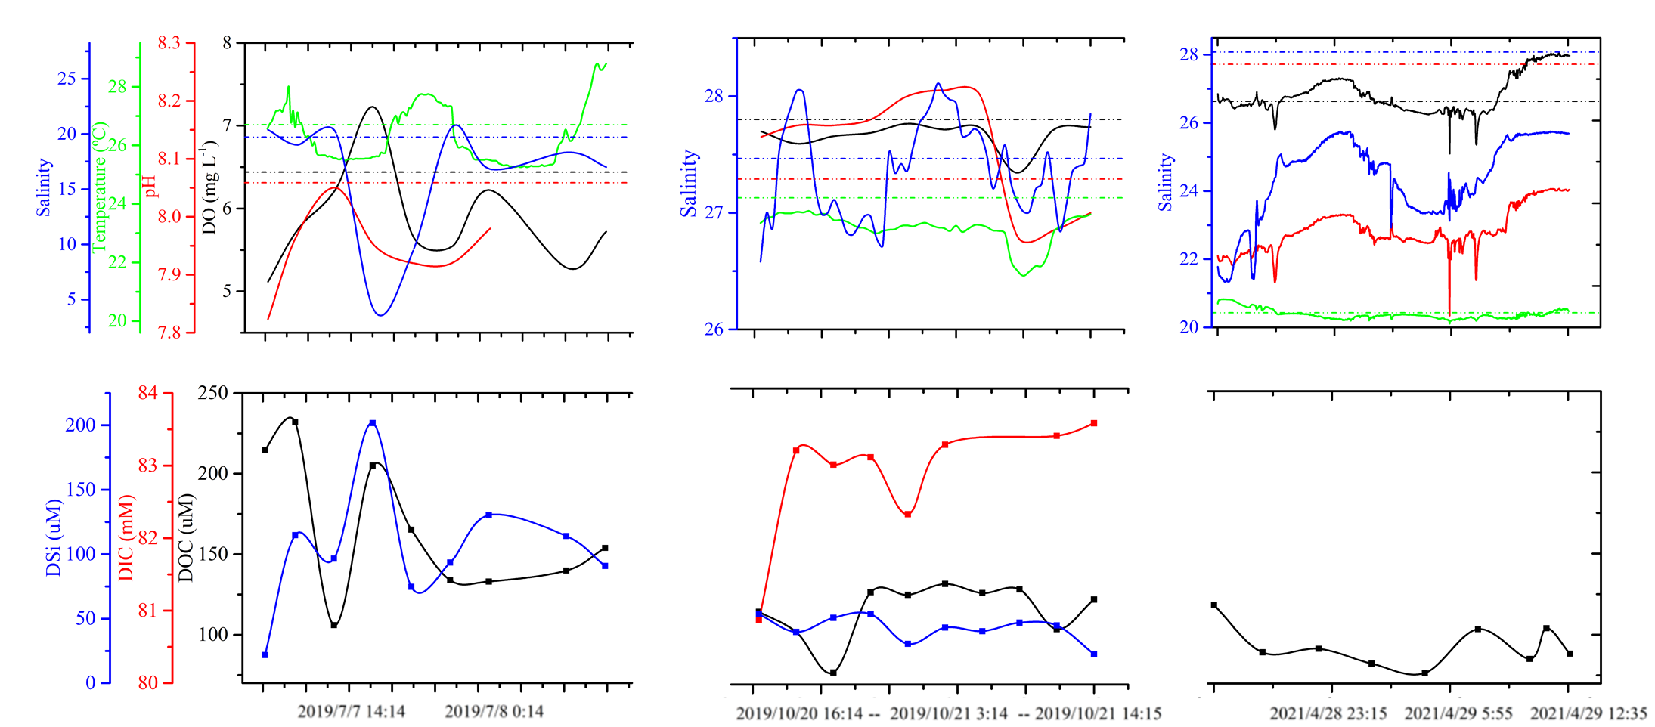

Figure S2. Temporal variation of groundwater flux and Fnet

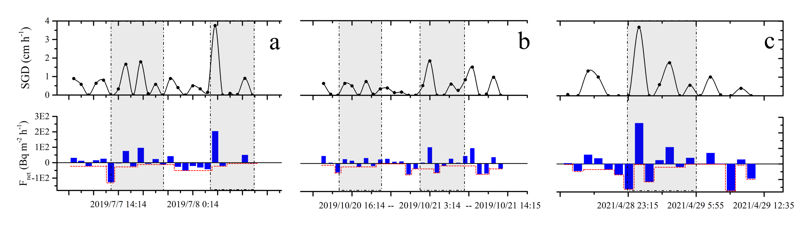

Burnett, W. C., Dulaiova, H., 2003. Estimating the dynamics of groundwater input into the coastal zone via continuous radon-222 measurements. *Journal of Environmental Radioactivity 69*, 21-35. <https://doi.org/10.1016/s0265-931x(03)00084-5>.

Chen, X. G., Zhang, F. F., Lao, Y. L., Wang, X. L., Du, J. Z., Santos, I. R., 2018. Submarine Groundwater Discharge-Derived Carbon Fluxes in Mangroves: An Important Component of Blue Carbon Budgets? *Journal of Geophysical Research: Oceans 123*, 6962-6979. <https://doi.org/10.1029/2018jc014448>.