*Supplementary material for*

**Using radium isotopes to quantify submarine groundwater discharge at different scales in the Yellow River Estuary, China**

Table S1. Water physico-chemical parameters and the activities of radium in surface waters of the Yellow River Estuary

|  |  |  |  |  |  |  |  |
| --- | --- | --- | --- | --- | --- | --- | --- |
| Station | Longi. | Lati. | depth | Tempt. | Sal. | 223Ra a | 224Ra a |
|  | /°E | /°N | /m | /℃ |  | /(dpm·m-3) | |
| June 2014 |  |  |  |  |  |  | |
| 1-T16 | 119.27 | 37.87 | 5.9 | 19.37 | 26.49 | 12.6±2.53 | 316±39.4 |
| 1-T17 | 119.26 | 37.89 | 10.7 | 23.22 | 23.66 | 17.0±3.11 | 518±35.8 |
| 1-T18 | 119.28 | 37.94 | 14.2 | 23.29 | 25.05 | 15.5±3.04 | 285±31.8 |
| 1-T19 | 119.29 | 37.98 | 15.5 | 23.13 | 26.41 | 13.4±2.79 | 123±21.0 |
| 1-T20 | 119.30 | 38.02 | 16.5 | 23.55 | 26.59 | 9.52±2.13 | 97.2±25.4 |
| 1-T21 | 119.28 | 37.86 | 2.5 | 21.85 | 22.44 | 12.2±2.54 | 317±33.7 |
| 1-T22 | 119.29 | 37.88 | 11.8 | 22.22 | 21.30 | 8.89±1.78 | 341±41.1 |
| 1-T23 | 119.31 | 37.93 | 14.8 | 22.88 | 26.30 | 12.8±2.67 | 49.1±16.6 |
| 1-T24 | 119.34 | 37.97 | 16.5 | 23.24 | 26.48 | 12.3±2.47 | 27.6±17.7 |
| 1-T25 | 119.36 | 38.01 | 16.9 | 23.50 | 26.53 | 8.55±2.14 | 64.2±17.4 |
| 1-T26 | 119.29 | 37.85 | 3.0 | 22.30 | 11.80 | 24.1±3.48 | 511±47.2 |
| 1-T27 | 119.31 | 37.87 | 11.0 | 20.17 | 25.80 | 10.0±1.77 | 270±34.8 |
| 1-T28 | 119.35 | 37.90 | 14.5 | 20.48 | 24.44 | 11.3±2.74 | 233±26.2 |
| 1-T29 | 119.38 | 37.94 | 16.1 | 21.75 | 26.64 | 4.27±1.04 | 34.3±34.3 |
| 1-T30 | 119.42 | 37.97 | 17.2 | 22.03 | 26.52 | 18.9±3.57 | 51.0±21.9 |
| 1-T31 | 119.30 | 37.82 | 2.7 | 22.37 | 23.76 | 26.3±2.53 | 499±48.9 |
| 1-T32 | 119.33 | 37.85 | 11.0 | 20.95 | 25.87 | 15.4±2.54 | 251±28.6 |
| 1-T33 | 119.37 | 37.88 | 14.8 | 21.47 | 26.64 | 9.30±1.98 | 55.2±15.7 |
| 1-T34 | 119.42 | 37.91 | 16.6 | 21.53 | 26.55 | 6.83±1.66 | 102±24.6 |
| 1-T35 | 119.46 | 37.94 | 17.6 | 21.31 | 26.76 | 6.24±1.61 | 49.4±16.0 |
| 1-T36 | 119.30 | 37.81 | 3.3 | 22.49 | 23.79 | 15.1±1.85 | 486±38.9 |
| 1-T37 | 119.35 | 37.84 | 11.0 | 20.94 | 25.63 | 14.9±2.33 | 214±25.8 |
| 1-T38 | 119.40 | 37.86 | 15.0 | 21.80 | 26.73 | 11.6±2.22 | 113±26.8 |
| 1-T39 | 119.44 | 37.88 | 16.6 | 21.46 | 26.49 | 8.72±2.00 | 89.6±16.8 |
| 1-T40 | 119.49 | 37.91 | 17.4 | 21.47 | 26.48 | 6.81±1.76 | 73.4±18.9 |
| 1-T41 | 119.31 | 37.80 | 5.3 | 20.83 | 25.67 | 15.8±3.44 | 378±39.7 |
| 1-T42 | 119.36 | 37.82 | 12.2 | 21.05 | 26.43 | 32.0±4.93 | 372±29.9 |
| 1-T43 | 119.42 | 37.83 | 14.6 | 20.84 | 26.47 | 19.1±2.97 | 243±29.7 |
| 1-T44 | 119.47 | 37.85 | 16.1 | 21.12 | 26.83 | 7.41±1.80 | 31.1±16.0 |
| 1-T45 | 119.52 | 37.86 | 16.9 | 20.77 | 26.62 | 6.26±1.98 | 39.1±16.6 |
| 1-T46 | 119.32 | 37.79 | 5.9 | 22.26 | 25.52 | 15.8±3.52 | 442±38.04 |
| 1-T47 | 119.38 | 37.80 | 11.8 | 21.93 | 25.88 | 14.4±3.15 | 258±25.0 |
| 1-T48 | 119.43 | 37.80 | 14.6 | 21.91 | 26.36 | 17.6±2.21 | 140±24.7 |
| 1-T49 | 119.49 | 37.81 | 15.4 | 21.45 | 26.84 | 9.35±2.15 | 151±19.6 |
| 1-T50 | 119.55 | 37.82 | 16.2 | 21.53 | 27.29 | 3.88±1.29 | 71.6±14.8 |
| Average b |  |  |  |  |  | 13.0±6.12 | 208±159 |
| July 2014 |  |  |  |  |  |  |  |
| 2-T16 | 119.27 | 37.88 | 5.9 | 22.89 | 19.66 | 22.8±3.80 | 1370±44.6 |
| 2-T17 | 119.26 | 37.89 | 10.7 | 25.49 | 15.86 | 35.2±4.66 | 1210±41.4 |
| 2-T18 | 119.28 | 37.94 | 14.2 | 24.96 | 12.76 | 34.0±4.54 | 1800±47.2 |
| 2-T19 | 119.29 | 37.98 | 15.5 | 23.64 | 25.54 | 18.5±3.70 | 301±31.2 |
| 2-T20 | 119.30 | 38.02 | 16.5 | 23.25 | 27.14 | 6.03±2.01 | 121±16.6 |
| 2-T21 | 119.28 | 37.86 | 2.5 | 21.13 | 25.90 | 11.3±2.58 | 647±32.1 |
| 2-T22 | 119.29 | 37.88 | 11.8 | 23.36 | 7.77 | 18.6±3.23 | 694±31.3 |
| 2-T23 | 119.31 | 37.93 | 14.8 | 21.73 | 21.16 | 14.6±3.10 | 889±43.5 |
| 2-T24 | 119.34 | 37.97 | 16.5 | 22.65 | 21.97 | 22.8±4.16 | 794±32.3 |
| 2-T25 | 119.36 | 38.01 | 16.9 | 23.73 | 20.83 | 11.3±3.13 | 715±31.2 |
| 2-T26 | 119.29 | 37.85 | 3.0 | 23.47 | 24.20 | 25.4±5.07 | 1060±55.1 |
| 2-T27 | 119.31 | 37.87 | 11.0 | 23.79 | 24.86 | 38.9±6.48 | 1090±44.2 |
| 2-T28 | 119.35 | 37.90 | 14.5 | 25.67 | 25.95 | 19.1±4.94 | 478±27.7 |
| 2-T29 | 119.38 | 37.94 | 16.1 | 22.38 | 23.83 | 23.8±5.29 | 768±33.8 |
| 2-T30 | 119.42 | 37.97 | 17.2 | 22.74 | 23.19 | 31.2±4.94 | 770±37.2 |
| 2-T31 | 119.30 | 37.82 | 2.7 | 21.86 | 24.70 | 21.8±5.44 | 824±35.2 |
| 2-T32 | 119.33 | 37.85 | 11.0 | 21.77 | 22.33 | 31.7±6.92 | 793±42.9 |
| 2-T33 | 119.37 | 37.88 | 14.8 | 21.58 | 23.33 | 31.2±6.64 | 1040±44.5 |
| 2-T34 | 119.42 | 37.91 | 16.6 | 22.52 | 22.30 | 41.3±7.54 | 972±54.9 |
| 2-T35 | 119.46 | 37.94 | 17.6 | 23.34 | 22.02 | 18.4±5.11 | 377±28.9 |
| 2-T36 | 119.30 | 37.81 | 3.3 | 22.95 | 22.76 | 32.4±6.47 | 1000±48.7 |
| 2-T37 | 119.35 | 37.84 | 11.0 | 23.64 | 20.62 | 31.9±6.96 | 1560±61.3 |
| 2-T38 | 119.40 | 37.86 | 15.0 | 24.93 | 15.74 | 24.9±5.56 | 1590±54.8 |
| 2-T39 | 119.44 | 37.88 | 16.6 | 25.55 | 16.37 | 22.3±5.58 | 1160±37.5 |
| 2-T40 | 119.49 | 37.91 | 17.4 | 25.50 | 23.43 | 16.6±4.29 | 497±34.9 |
| 2-T41 | 119.31 | 37.80 | 5.3 | 23.15 | 24.29 | 20.6±5.33 | - |
| 2-T42 | 119.36 | 37.82 | 12.2 | 22.77 | 26.70 | 12.9±3.73 | 640±34.1 |
| 2-T43 | 119.42 | 37.83 | 14.6 | 24.34 | 25.68 | 28.9±6.32 | 623±40.7 |
| 2-T44 | 119.47 | 37.85 | 16.1 | 25.13 | 25.46 | 26.2±6.35 | 473±40.2 |
| 2-T45 | 119.52 | 37.86 | 16.9 | 25.04 | 26.30 | 6.66±2.98 | 198±16.8 |
| 2-T46 | 119.32 | 37.79 | 5.9 | 25.16 | 22.24 | 23.5±5.53 | 866±40.5 |
| 2-T47 | 119.38 | 37.80 | 11.8 | 23.95 | 25.62 | 28.2±6.83 | 580±31.9 |
| 2-T48 | 119.43 | 37.80 | 14.6 | 23.46 | 25.92 | 24.0±6.18 | 416±28.3 |
| 2-T49 | 119.49 | 37.81 | 15.4 | 23.84 | 26.58 | 15.2±4.81 | 187±21.3 |
| 2-T50 | 119.55 | 37.81 | 16.2 | 24.80 | 26.96 | 11.7±4.14 | 129±21.1 |
| Average b |  |  |  |  |  | 23.0±8.80 | 761±434 |
| July 2016 |  |  |  |  |  |  |  |
| 1 | 119.32 | 37.79 | 6.1 | 26.00 | 7.11 | 24.3±3.44 | 599±26.1 |
| 2 | 119.38 | 37.80 | 12.1 | 25.60 | 7.21 | 31.1±4.02 | 464±26.0 |
| 3 | 119.43 | 37.80 | 14.2 | 26.00 | 7.65 | 21.6±3.76 | 261±22.7 |
| 4 | 119.49 | 37.81 | 15.5 | 27.50 | 9.23 | 9.20±1.92 | 259±20.3 |
| 5S | 119.55 | 37.82 | 16.2 | 28.80 | 8.86 | 24.3±3.90 | 323±26.3 |
| 12 | 119.30 | 37.81 | 16.9 | 25.90 | 7.30 | 17.7±3.41 | 435±24.4 |
| 13 | 119.35 | 37.84 | 3.1 | 25.70 | 8.24 | 14.4±3.01 | 362±23.8 |
| 14 | 119.40 | 37.86 | 8.1 | 25.60 | 7.47 | 16.0±2.26 | 302±20.4 |
| 15 | 119.44 | 37.88 | 13.1 | 26.50 | 8.63 | 20.2±2.98 | 415±24.7 |
| 16 | 119.49 | 37.91 | 14.4 | 28.30 | 9.35 | 16.6±2.73 | 426±28.5 |
| 18 | 119.27 | 37.89 | 14.6 | 25.60 | 8.60 | 19.1±2.88 | 376±23.5 |
| 19S | 119.26 | 37.87 | 3.7 | 26.20 | 8.67 | 23.6±3.03 | 588±30.5 |
| 20 | 119.28 | 37.94 | 11.7 | 25.10 | 8.43 | 11.7±2.17 | 305±25.4 |
| 21S | 119.29 | 37.98 | 14.9 | 26.90 | 9.98 | 18.7±2.53 | 174±18.8 |
| 22 | 119.30 | 38.02 | 16.9 | 27.80 | 8.99 | 24.3±3.71 | 421±30.3 |
| 35 | 119.29 | 37.84 | 17.6 | 24.90 | 7.08 | 29.9±4.40 | 552±27.0 |
| 36 | 119.31 | 37.87 | 18.2 | 25.30 | 7.35 | 5.93±1.48 | 355±19.4 |
| 37 | 119.35 | 37.90 | 11.4 | 26.40 | 7.36 | 16.1±2.15 | 621±22.8 |
| 38S | 119.38 | 37.94 | 3.7 | 27.80 | 9.95 | 21.8±3.12 | 523±28.9 |
| 39 | 119.42 | 37.98 | 14.1 | 27.80 | 9.30 | 8.86±1.64 | 285±17.8 |
| Average b |  |  |  |  |  | 18.8±6.71 | 402±126 |
| May 2019 |  |  |  |  |  |  |  |
| S6 | 119.20 | 37.93 | 11.8 | 16.29 | 29.04 | 22.9±3.24 | 299±21.2 |
| Y5 | 119.29 | 37.95 | 15.3 | 15.18 | 28.65 | 16.5±2.75 | 363±25.8 |
| Y4 | 119.27 | 37.88 | 5.3 | 14.02 | 27.82 | 22.9±2.70 | 634±24.9 |
| Y3 | 119.28 | 37.87 | 4.4 | 14.14 | 26.71 | 26.3±3.68 | 529±27.9 |
| Y2 | 119.28 | 37.86 | 4.4 | 13.07 | 28.29 | 24.7±2.96 | 581±25.0 |
| M1-2 | 119.33 | 37.80 | 7.0 | 14.04 | 26.64 | 35.9±3.96 | 748±31.0 |
| M1-1 | 119.31 | 37.79 | 3.6 | 15.26 | 25.86 | 33.5±3.87 | 1020±32.6 |
| C2 | 119.40 | 37.79 | 13.3 | 13.02 | 27.89 | 20.5±3.28 | 477±27.9 |
| H1-3 | 119.48 | 38.02 | 18.8 | 13.75 | 28.94 | 14.6±2.09 | 151±15.5 |
| S7 | 119.59 | 37.88 | 17.7 | 16.43 | 26.38 | 18.8±2.37 | 410±20.3 |
| J1 | 119.43 | 37.90 | 17.0 | - c | - c | 15.2±2.09 | 386±20.9 |
| J2 | 119.51 | 37.79 | 15.5 | - c | - c | 22.0±3.08 | 331±22.2 |
| J3 | 119.38 | 37.72 | 11.0 | - c | - c | 63.1±7.82 | 1120±46.8 |
| J4 | 119.35 | 37.85 | 11.7 | - c | - c | 31.2±3.55 | 856±30.4 |
| Average b |  |  |  |  |  | 26.3±12.4 | 564±282 |

Note: a All Ra activities uncertainties were shown at the 1-σ level. b Geometric average values of all seawater samples in each cruise. c “-” means no data available.

Table S2. Radium activities in shallow groundwater collected near the coast of Yellow River estuary

|  |  |  |  |  |  |  |  |
| --- | --- | --- | --- | --- | --- | --- | --- |
| Station a | Longi. | Lati. | Tempt. | Sal. | 223Ra b | 224Ra b | |
|  | /°E | /°N | /℃ |  | /(dpm·m-3) | |
| June 2014 |  |  |  |  |  |  | |
| GW2 | 118.93 | 37.45 | 38.70 | 25.60 | 1070±229 | 33900±1570 | |
| GW4 | 118.92 | 37.54 | 23.00 | 23.50 | 739±191 | 18600±1350 | |
| GW5 | 118.98 | 37.63 | 41.80 | 22.20 | 272±75.6 | 19500±1180 | |
| GW6 | 119.21 | 37.73 | 29.90 | 29.90 | 598±141 | 23700±1250 | |
| GW7 | 119.25 | 37.73 | 25.70 | 28.60 | 1220±155 | 49800±2030 | |
| GW8 | 119.24 | 37.73 | 32.30 | 27.70 | 428±151 | 19900±1270 | |
| GW9 | 119.09 | 37.82 | 27.90 | 25.50 | 315±99.6 | 13500±765 | |
| GW10 | 119.09 | 37.89 | 25.90 | 24.60 | 97.9±37.0 | 4830±373 | |
| GW11 | 119.10 | 37.85 | 26.20 | 26.20 | 73.0±29.8 | 3760±267 | |
| July 2014 |  |  |  |  |  |  | |
| GW2 | 118.93 | 37.45 | 32.40 | 44.80 | 1010±164 | 28400±1400 | |
| GW4 | 118.92 | 37.54 | 33.40 | 26.00 | 439±93.5 | 15100±772 | |
| GW5 | 118.98 | 37.63 | 32.10 | 44.60 | 443±134 | 8230±533 | |
| GW6 | 119.21 | 37.73 | 29.30 | 20.62 | 498±166 | 14700±970 | |
| GW7 | 119.25 | 37.73 | 30.40 | 13.66 | 140±62.8 | 15500±864 | |
| GW8 | 119.24 | 37.73 | 31.30 | 31.30 | 585±177 | 25200±1260 | |
| GW10 | 119.09 | 37.89 | 28.70 | 28.30 | 36.7±16.4 | 6150±402 | |
| GW11 | 119.10 | 37.85 | 27.50 | 28.30 | 51.5±25.8 | 3140±288 | |
| May 2019 |  |  |  |  |  |  | |
| GW1 | 118.93 | 37.45 | 17.40 | 22.00 | 379±82.6 | 28200±1280 | |
| GW2 | 119.20 | 37.74 | 20.00 | 31.70 | 1070±125 | 19100±663 | |
| GW3 | 119.10 | 37.82 | 19.20 | 18.50 | 487±78.0 | 16500±657 | |
| GW4 | 119.10 | 37.85 | 19.50 | 33.40 | 397±66.2 | 13200±570 | |
| GW5 | 119.10 | 37.89 | 19.30 | 31.90 | 197±36.0 | 10500±433 | |

Note: a Samples named by “GW” were collected groundwater samples from the study site during these two investigations.  b All Ra activities uncertainties were shown at the 1-σ level.



Fig. S1. Triangle elements for calculation of area, volume, and radium stock in Yellow River Estuary.

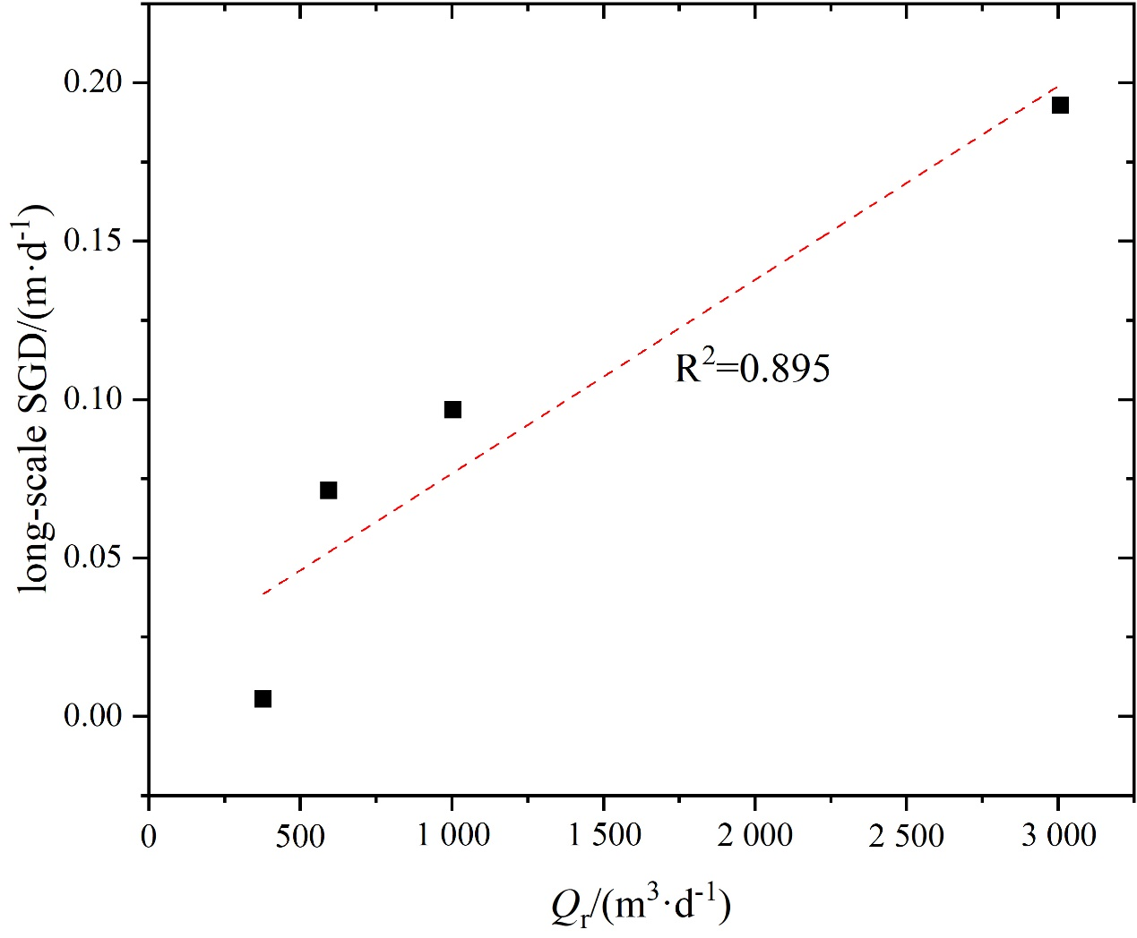

Fig. S2. Relationship between *Q*r and long-scale SGD rate